MUSEUM DATABASE

Contents
1 Business Description 3
1.1 Business background 3
1.2 Problems 3
1.3 The benefits of implementing a database. Project Vision 3
2 Model description 3
2.1 Definitions & Acronyms 3
2.2 Logical Scheme 3
2.3 Objects 3

1. BUSINESS DESCRIPTION
1.1 BUSINESS BACKGROUND
Museums manage a diverse range of cultural, historical, and scientific assets. Each item in the collection — artworks, archaeological artifacts, fossils, or documents — must be cataloged, preserved, and tracked throughout its lifecycle.
Operational activities include storing items in controlled environments, organizing exhibitions, selling tickets to visitors, and coordinating employees such as curators, guides, and cashiers.

However, these activities generate large volumes of heterogeneous data: inventory details, storage records, exhibition schedules, visitor information, ticket sales, and employee responsibilities. Without a centralized system, the museum faces challenges in maintaining accurate records, tracking object movement, and producing meaningful analytical reports.

1.2 PROBLEMS
Currently, museum-related information is fragmented:
- Inventory data is often stored in separate spreadsheets or legacy systems.
- Storage history (where items were stored and when) is maintained manually.
- Exhibition planning is disconnected from item metadata and curator assignments.
- Ticket sales data is separate from visitor information and cannot be easily aggregated for analytics.
- Employee responsibilities (e.g., who curated which exhibition) are not systematically linked.
Because the data is dispersed, the museum cannot efficiently:
- Track item movement or exhibition participation
- Understand revenue patterns
- Analyze visitor trends
- Identify top-performing exhibitions
- Produce consistent quarterly reports
This fragmentation increases administrative workload and reduces decision-making accuracy.

1.3 THE BENEFITS OF IMPLEMENTING A DATABASE
The proposed relational database will:
- Centralize all museum information in one consistent, normalized structure
- Eliminate redundancy and ensure data integrity through keys, constraints, and 3NF modeling
- Track item storage history, improving preservation management
- Link items to exhibitions, enabling planning and reporting
- Store visitor and ticket sales data, enabling automated quarterly analytics
- Support employee management, including curator assignment
- Enable secure access, including a read-only role for museum managers
The database establishes a scalable foundation for operational efficiency, accurate reporting, and long-term digital transformation of museum workflows.

2 MODEL DESCRIPTION
2.1 DEFINITIONS & ACRONYMS
- 3NF: Third Normal Form, ensuring no partial or transitive dependencies.
- PK: Primary Key
- FK: Foreign Key
- M:N: Many-to-many relationship, resolved via junction tables.
- Surrogate Key: Auto-generated numeric identifier
- Natural Key: Meaningful real-world identifier such as employee_no or accession_code

2.2 LOGICAL SCHEME
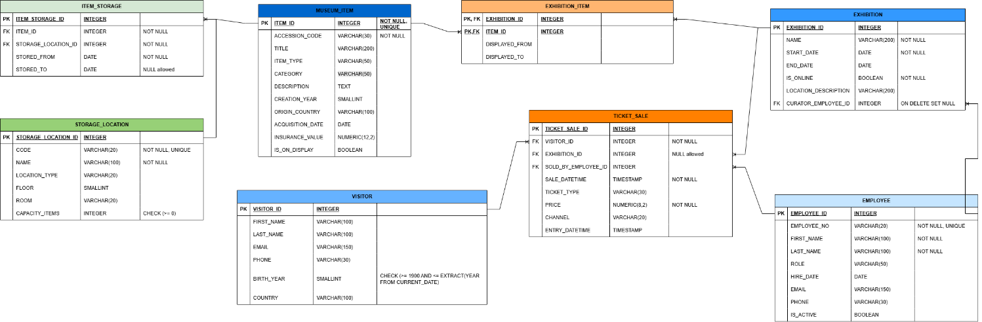
Tables included:
- MUSEUM_ITEM
- STORAGE_LOCATION
- ITEM_STORAGE (M:N resolution)
- EXHIBITION
- EXHIBITION_ITEM (M:N resolution)
- EMPLOYEE
- VISITOR
- TICKET_SALE
All relationships and cardinalities match the conceptual model:
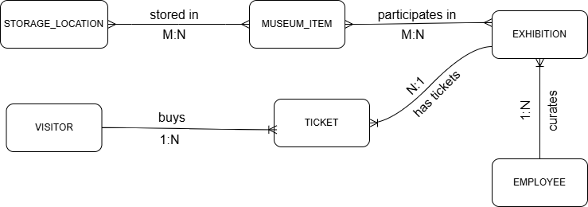
2.3 OBJECTS
- MUSEUM_ITEM TABLE
Represents all items in the museum’s collection, including artworks, artifacts, fossils, and historical objects.
Table Name | Field name | Field Description | Data Type
MUSEUM_ITEM | ITEM_ID | Unique identifier (PK) | BIGINT
MUSEUM_ITEM | ACCESSION_CODE | Internal museum inventory code (UNIQUE) | VARCHAR(30)
MUSEUM_ITEM |  | Item title | VARCHAR(200)
  TITLE
MUSEUM_ITEM |  | Object type (painting, sculpture, fossil, etc.) | VARCHAR(50)
  ITEM_TYPE
MUSEUM_ITEM |  | Broad classification | VARCHAR(50)
  CATEGORY
MUSEUM_ITEM | DESCRIPTION | Longer text describing the item | TEXT
MUSEUM_ITEM | CREATION_YEAR | Approx. year of creation | SMALLINT
MUSEUM_ITEM | ORIGIN_COUNTRY | Country of origin | VARCHAR(100)
MUSEUM_ITEM | ACQUISITION_DATE | When museum acquired the item | DATE
MUSEUM_ITEM | INSURANCE_VALUE | When museum acquired the item | NUMERI(12,2)
MUSEUM_ITEM | IS_ON_DISPLAY | Whether currently displayed | BOOLEAN

Comments on table relationships
Each museum item:
- Can be stored in multiple storage locations over time (via Item_Storage M:N bridge)
- Can participate in many exhibitions (via Exhibition_Item M:N bridge)

Example with data

Item_id | Accession_code | Title | Creation_year
1 | ACC-0001 | Portrait of a Woman | 1885

- STORAGE_LOCATION TABLE
Defines physical or restoration spaces where museum items are stored.

Table Name | Field name | Field Description | Data Type
STORAGE_LOCATION | STORAGE_LOCATION_ID | Unique identifier (PK) | BIGINT
STORAGE_LOCATION | CODE | Location code(UNIQUE) | VARCHAR(20)
STORAGE_LOCATION | NAME |  | VARCHAR(100)
  Name of storage area
STORAGE_LOCATION |  | GALLERY / STORAGE / RESTORATION | VARCHAR(20)
  LOCATION_TYPE
STORAGE_LOCATION | FLOOR | Floor number | SMALLINT
STORAGE_LOCATION | ROOM | Room identifier | VARCHAR(20)
STORAGE_LOCATION | CAPACITY_ITEMS | Maximum storage capacity | INTEGER

Comments on table relationships
Represents locations linked to museum items through the M:N table Item_Storage.
Example with data

STORAGE_LOCATION_ID | CODE | NAME | LOCATION_TYPE
1 | GL-A1 | MAIN GALLERY A | GALLERY
- ITEM_STORAGE TABLE
Bridge table resolving the M:N relationship between museum items and storage locations.

Table Name | Field name | Field Description | Data Type
ITEM_STORAGE | ITEM_STORAGE_ID | Unique identifier (PK) | BIGINT
ITEM_STORAGE | ITEM_ID | References Museum_Item (FK) | BIGINT
ITEM_STORAGE | STORAGE_LOCATION_ID |  | BIGINT
  References Storage_Location (FK)
ITEM_STORAGE |  |  | DATE
  STORED_FROM
  Start date of storage period
ITEM_STORAGE | STORED_TO | End date (nullable) | DATE

Comments on table relationships
- Tracks storage history.
- One item may appear in multiple storage locations over time.
Example with data

ITEM_STORAGE_ID | ITEM_ID | STORAGE_LOCATION_ID | STORED_FROM
1 | 1 | 4 | 2024-11-01

- EXHIBITION TABLE
Represents museum exhibitions (physical or online) displaying museum items.

Table Name | Field name | Field Description | Data Type
EXHIBITION | EXHIBITION_ID | Unique identifier (PK) | BIGINT
EXHIBITION | NAME | Exhibition title | VARCHAR(200)
EXHIBITION | START_DATE |  | DATE
  Start date
EXHIBITION |  |  | DATE
  END_DATE
  End date
EXHIBITION |  | Whether exhibition is online | BOOLEAN
  IS_ONLINE
EXHIBITION | LOCATION_DESCRIPTION | Brief location info | VARCHAR(200)
EXHIBITION | CURATOR_EMPLOYEE_ID | References Employee (FK) | BIGINT

Comments on table relationships
- One curator (employee) may manage many exhibitions
- Each exhibition includes many items through Exhibition_Item
Example with data

exhibition_id | name | start_date
1 |  | 2024-11-20
  Impressionist Portraits

- EXHIBITION_ITEM TABLE
Bridge table resolving M:N relationship between Museum_Item and Exhibition.

Table Name | Field name | Field Description | Data Type
EXHIBITION_ITEM | EXHIBITION_ID | References Exhibition (FK) | BIGINT
EXHIBITION_ITEM | ITEM_ID | References Museum_Item (FK) | BIGINT
EXHIBITION_ITEM | DISPLAYED_FROM |  | DATE
  Start date of display
EXHIBITION_ITEM |  |  | DATE
  DISPLAYED__TO
  End date

Comments on table relationships
- Each record indicates that a specific item was displayed in a specific exhibition during a defined period.
Example with data

EXHIBITION_ID | ITEM_ID | DISPLAYED_FROM
1 | 1 | 2024-11-25

- EMPLOYEE TABLE
Contains museum staff information, including curators, guides, cashiers, and security.

Table Name | Field name | Field Description | Data Type
EMPLOYEE | EMPLOYEE_ID | Unique identifier (PK) | BIGINT
EMPLOYEE | EMPLOYEE_NO | Natural key, unique employee code | VARCHAR(20)
EMPLOYEE | FIRST_NAME |  | VARCHAR(100)
  Employee first name
EMPLOYEE |  |  | VARCHAR(100)
  LAST_NAME
  Employee last name
EMPLOYEE | ROLE | Job role | VARCHAR(50)
EMPLOYEE | HIRE_DATE |  | DATE
  Hiring date
EMPLOYEE | EMAIL | Email address | VARCHAR(150)
EMPLOYEE | PHONE |  | VARCHAR(30)
  Phone
EMPLOYEE | IS_ACTIVE | Employment status | BOOLEAN
EMPLOYEE | FULL_NAME
  Generated as first_name

Comments on table relationships
Employees curate exhibitions and sell tickets.
Example with data

EMPLOYEE_ID | EMPLOYEE_NO | ROLE
1 | EMP-001 | CURATOR

- VISITOR TABLE
Stores visitor information.

Table Name | Field name | Field Description | Data Type
VISITOR | VISITOR_ID | Unique identifier (PK)
  BIGINT
VISITOR | FIRST_NAME | Visitor first name | VARCHAR(100)
VISITOR | LAST_NAME |  | VARCHAR(100)
  Visitor last name
VISITOR |  |  | VARCHAR(150)
  EMAIL
  Contact email
VISITOR |  |  | VARCHAR(30)
  PHONE
  Phone number
VISITOR | BIRTH_YEAR |  | SMALLINT
  Birth year
VISITOR | COUNTRY |  | VARCHAR(100)
  Nationality
VISITOR | FULL_NAME | Generated full name | TEXT

Comments on table relationships
A visitor may purchase multiple tickets.
Example with data

VISITOR_ID | FIRST_NAME | COUNTRY
1 | Emma | USA
- TICKET_SALE TABLE
Represents ticket sale transactions.

Table Name | Field name | Field Description | Data Type
TICKET_SALE | TICKET_SALE_ID | Unique transaction ID (PK) | BIGINT
TICKET_SALE | VISITOR_ID |  | BIGINT
  References Visitor (FK)
 | EXHIBITION_ID |  | BIGINT
  References Exhibition (FK)
 |  | References Employee (FK) | BIGINT
  SOLD_BY_EMPLOYEE_ID
 | SALE_DATETIME |  | TIMESTAMP
  Timestamp of sale
 | ENTRY_DATETIME | Time visitor entered | TIMESTAMP
 | TICKET_TYPE | Type (ADULT, STUDENT, etc.) | VARCHAR(30)
 | PRICE |  | NUMERIC(8,2)
  Final price
 | CHANNEL | Sales channel | VARCHAR(20)
 | SALE_QUARTER_START | Generated quarter start date | DATE

Comments on table relationships
Used in quarterly analytics.
Example with data

TICKET_SALE_ID | VISITOR_ID | PRICE
1 | 1 | 25.00

